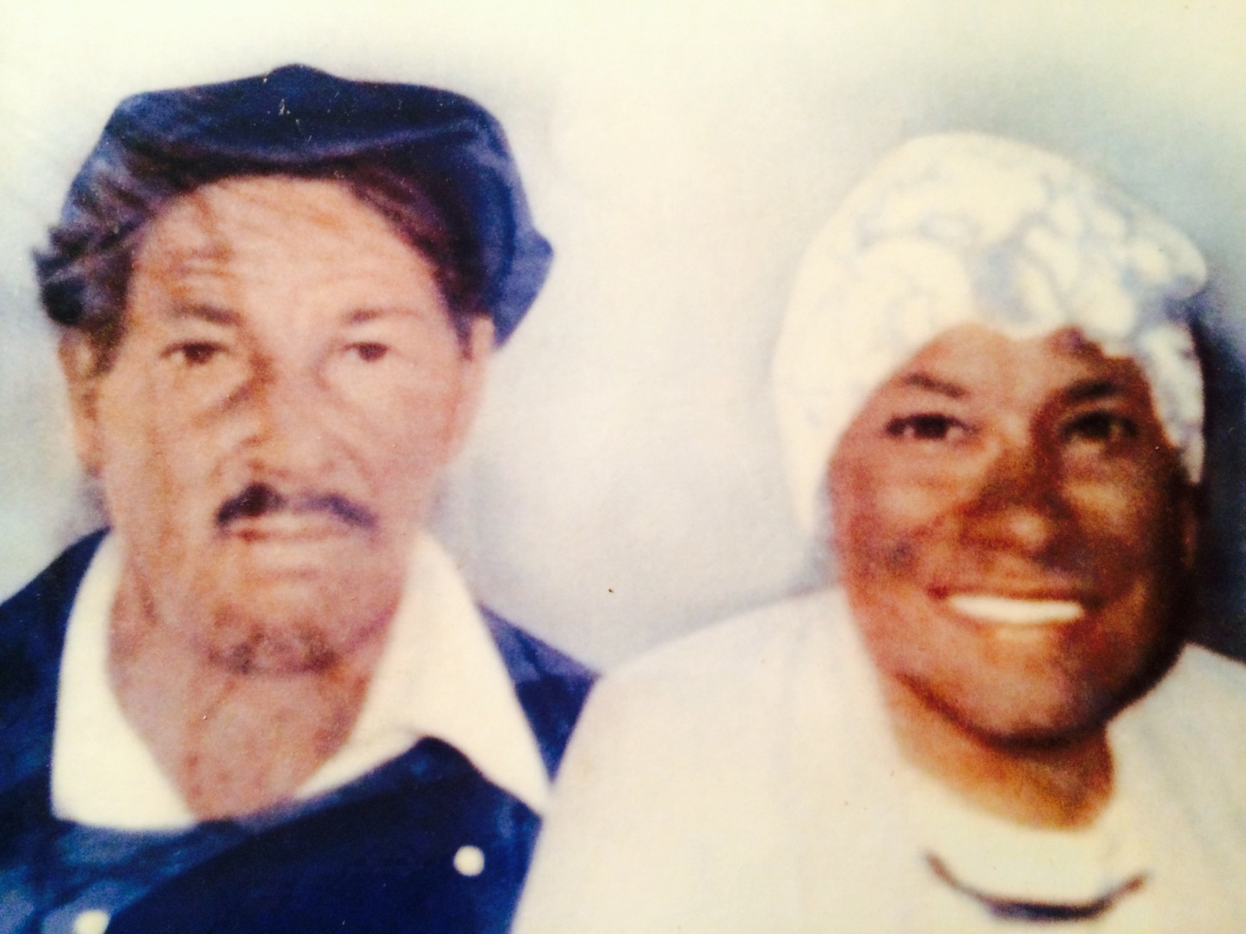
2022 Kemp Family Reunion
You’re Invited!

Hello Kemp Family!
It’s Reunion time again! This is your official invitation to the 2022 Kemp Family Reunion. The Reunion will be held on Saturday, July 2, 2022 and we are looking forward to seeing you there. An overview of our 1-day reunion celebration is below.
Saturday, July 2 10 am to 10:30 am Memorial Service
Location: Gravesite of Ed and Isadora Kemp, Whiteville, NC
12 noon Lunch and Family Reunion Activities Catered by Dowless Catering
Location: Lu Mil Vil Vineyard, 438 Suggs-Taylor Road, Elizabethtown, NC
Stay tuned to our Facebook Community: “Kemp Family Reunion,” or log on to our reunion website at www.kempfamilyreunion.com for more information the reunion, family history and so much more.
As in the past, the cost to attend is $35 per person, which includes a catered lunch, registration goodie bag, entertainment and activities for all ages, as well as a family reunion t-shirt. Kids age 5 and under eat free. This year, polo shirts are available for an additional cost reflected in the registration form. The color for this year is "Carolina Blue."
COVID-19 precautions will be taken, including temperature checks and masks. Please bring proof of vaccination, proof of negative test in last 5 days, or if unvaccinated we’ll have rapid tests on hand. We’re looking forward to a safe and enjoyable time together!
This year we really want to celebrate our young people. We know the younger generation is dealing with new and ever-growing challenges and we want the Kemp Family Reunion to be a place where they can continue growing and building the right foundation for their own strong legacies. On the registration form, for all young attendees, please include any accomplishments, awards, or community service that can be recognized during the reunion.

It’s easy for everyone to participate in this year’s reunion. Here are a few things to keep in mind:
- If you’d like to attend but do not want a shirt, the cost is $25 per person.
- Even if you are unable to attend the family reunion, you can still order a shirt or donate to the Kemp Family Reunion Scholarship Fund. T-shirts are $12 for adult sizes/$10 for youth sizes and polo shirts are $18 for adults/$16 for youth sizes. Please use the registration form to make your shirt order or to contribute to the Scholarship Fund.
Forms are available through Family Representatives, or you may download and print them from the family reunion website. Please complete and return both the printed form and payments to Louise Elkins at the following address: 491 Maple Branches Drive, Belville, NC 28451. Checks should be made payable to Kemp Family Reunion.
If you are visiting from out of town and need hotel accommodations, here are a couple of options. Lu Mil Vineyard offers several quaint cabins on-site. Please visit www.lumilvineyard.com to view and reserve. Prices range from $115-$145 per night. Other hotel options include:
Econo Lodge 503 N J.K. Powell Blvd, Whiteville, NC 28472 Tel: (910) 642-2378
Quality Inn 1415 J.K. Powell Blvd, Whiteville, NC 28472 Tel: (910) 641-0644
The deadline for submitting payment is June 3, 2022. Please make every effort to join us for this year’s festivities. We’re looking forward to seeing you there!

Sincerely,
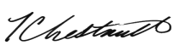
T.C. Chestnutt, President, Kemp Family Reunion

Family Representatives
Eugene and LaVerne George | Thurman and Brenda Chestnutt | Barbara McKenzie
Louise Elkins | Gloria Shipman | Vanessa Shipman
Tommy Kemp | Annie Jean Chestnut | Cynthia Hill

